- Place all programs in desired locations, keep the sim_TA_v_1p06, and Function_Library_RH_v1p11 programs together
- Change this line in the gen_TA_v_1p07 program
Point the path to where the other two programs (sim_TA_v_1p06, and Function_Library_RH_v1p11) are located
- Run the gen_TA_v_1p07 program
- Two windows should open, most of the larger window can be ignored, on the second smaller window that looks like the following
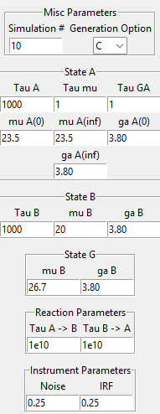
Parameters for the simulation can be entered (always leave the generation options to C)
- When the desired simulation parameters are set press the run sim button in the larger window (the rest of the window can be ignored)
- Once the simulation is generated you will be prompted to save the file, choose a desired location
- Make sure that files are saved in separate locations if the lambda plus and minus values will be the same as these values are used to generate the file name resulting in overwriting of previous simulations
- The parameter window has state A that contains all parameters relevant to state A such as the lifetime, shift lifetime, width change lifetime, start and ending center point of state A gaussian in 1000s of wavenumbers, and initial and final FWHM of the state A gaussian in 1000s of wavenumbers
- State B parameter window contains the lifetime of state B, the center point of the gaussian of state B in 1000s of wavenumbers, and the FWHM of the state B gaussian in 1000s of wavenumbers
- State G the ground state bleach contains only the centerpoint and FWHM of the state G gaussian
- Reaction parameters contains the rate of A to B and the rate of B to A, setting either to a large number effectively disables the process
- Finally the instrument parameters allow the adjustment of the noise and IRF

